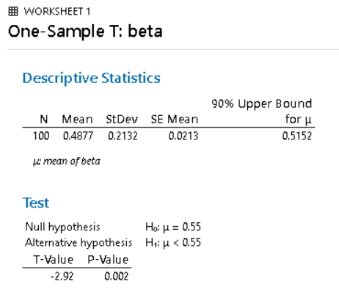
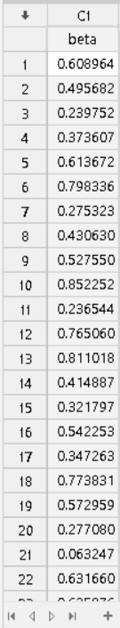
1a 1b

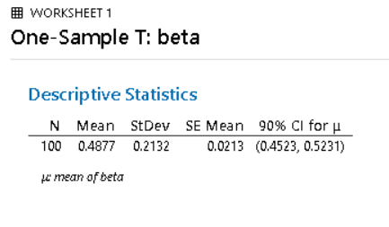
1b

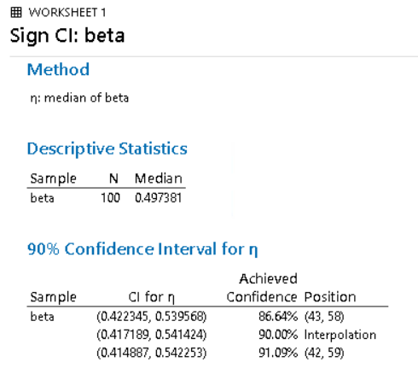
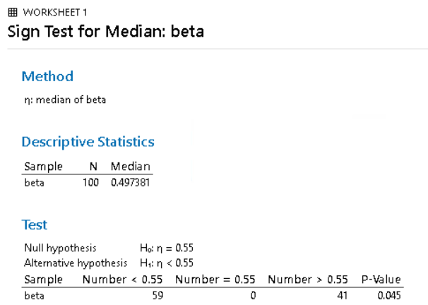
1c 1c

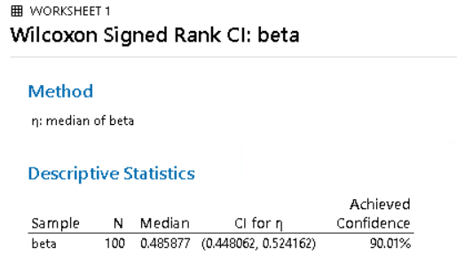
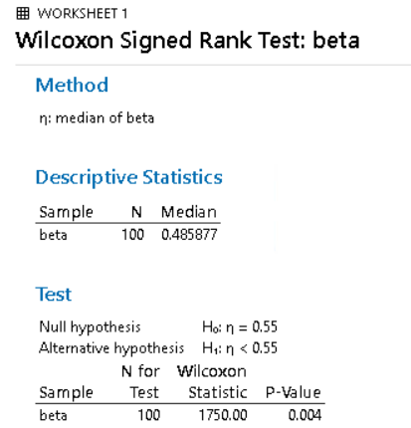
1d 1d

1e The sign test had the further p-value from the t-test than the signed-rank test which aligns with the ARE of 225/448. The signed-rank test had a very similar p-value to the t-test which corresponds with the ARE of 300/343.

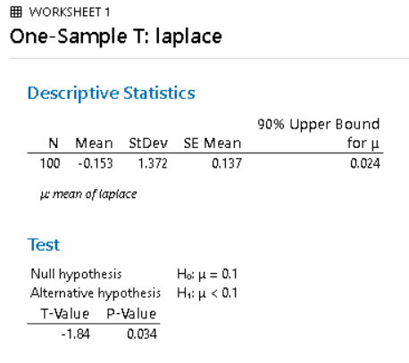
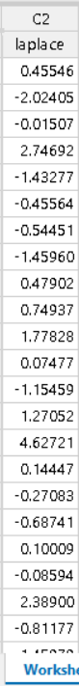
2a 2b

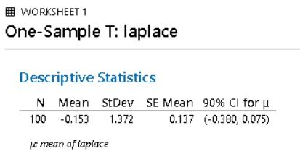
2b

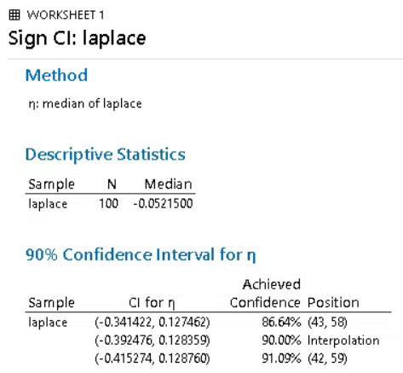
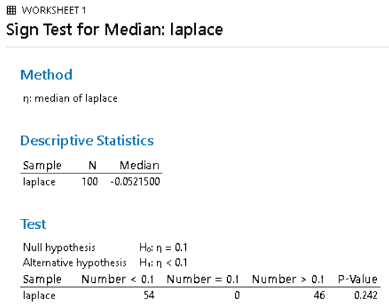
2c 2c

2d 2d
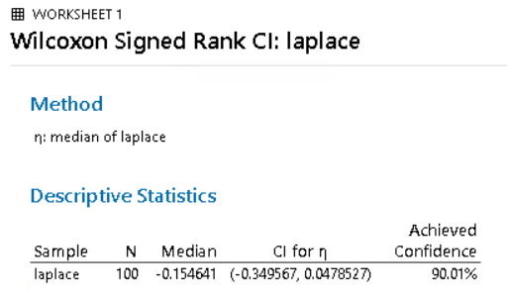
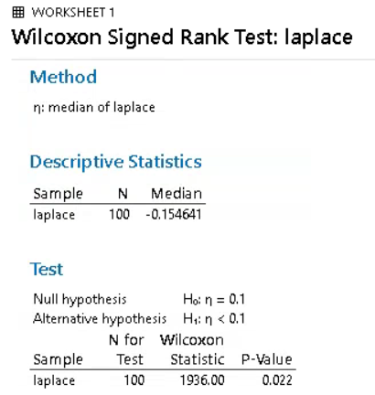

2e The confidence interval for the sign test is more conservative than both the t-test and the signed-rank test which corresponds to the ARE of 2. The confidence interval for the signed-rank test was more conservative than the t-test but not as conservative as the sign test which aligns with the ARE of 1.5

3a diffN2<-c(-6,-5,-10,0,6,-3,-9,-12,3,3,-11,-8,-12,-7,8,-4,-12)
centerdiff<-c(-10.5,-9.5,5.5,-4.5,1.5,-7.5,-13.5,-16.5,-1.5,-1.5,-15.5,-12.5,-16.5,-11.5,3.5,-8.5,-5.5,-2.5)
RFPW(centerdiff)
$obs.stat
[1] 0.6784137
$p.val
[1] 0.4975094
3b Symmetry.test(centerdiff,option=”MGG”,side=”both”,boot=TRUE,B=100000)
m-out-of-n bootstrap symmetry test by Miao, Gel, and Gastwirth (2006)
data: centerdiff
Test statistic = 0.74677, p-value = 0.5462
alternative hypothesis: the distribution is asymmetric.
sample estimates:
bootstrap optimal m
18
3c symmetry_test(centerdiff,stat=”WCX”,mu=0,exact=TRUE,B=100000)
Symmetry test
Null hypothesis: Data is symmetric around 0
data: centerdiff
WCX=0.15251, B=1e+05, P-value=0.8197

3d -1.5, 1.5, -2.5, -3.5, 3.5, -4.5, 4.5, -5.5, 6.5, -6.5, -7.5, 7.5, 7.5, -7.5, 10.5, 12.5 (omit 0.5, and -0.5 because of forced tie)
Ranks: 1.5, 1.5, 3, 4.5, 4.5, 6.5, 6.5, 8, 9.5, 9.5, 12.5, 12.5, 12.5, 12.5, 15, 16
T⁺ = 1.5+4.5+6.5+9.5+12.5+12.5+15+16=78
Minimum – lower 8 ranks = 1.5, 1.5, 3, 4.5, 4.5, 6.5, 6.5, 8 total=36
Maximum – upper 8 ranks = 9.5, 9.5, 12.5, 12.5, 12.5, 12.5, 15, 16 total=100
I would expect the p-value to be large since the test statistic T⁺=78 is not close to the tail.
3e It would not be appropriate to make inferences on the median of this data set using the signed-rank procedures based on the results of the symmetry tests. The reason is because we would fail to reject the null hypothesis that the data is symmetric. The disadvantage of not using the signed-rank procedures when they are appropriate is that the test would assume the data is normally distributed. The disadvantage of using the signed-rank procedures when they are not appropriate is that they are overly conservative and produce larger p-values which could cause a Type II error.

